A Machine Learning Model for Average Fuel Consumption in Heavy Vehicles

In this paper author is describing concept to predict average fuel consumption in heavy vehicles using Machine Learning Algorithm such as ANN (Artificial Neural Networks). To predict fuel consumption author has extracted 7 predictor features from heavy vehicle dataset such as

num_stops, time_stopped, average_moving_speed, characteristic_acceleration, aerodynamic_speed_squared, change_ in_kinetic_energy, change_in_potential_energy, class

Above seven features are recorded from each vehicle travel up to 100 kilo meters like number of times vehicle stop, total stopped time taken etc. All this values are collected from heavy vehicle and use as dataset to train ANN model. Below are some value from above seven predictor features.

num_stops, time_stopped, average_moving_speed, characteristic_acceleration, aerodynamic_speed_squared, change_ in_kinetic_energy, change_in_potential_energy, class

7.0, 7.0, 93.0, 34, 8.4, 4, 25.6, 9
7.0, 7.0, 91.0, 34, 8.3, 4, 25.7, 9
8.9, 8.9, 151.0, 26, 10.9, 6, 15.1, 12
9.3, 9.3, 160.0, 25, 11.3, 6, 13.7, 13
8.4, 8.4, 158.0, 25, 11.2, 6, 13.8, 13

All bold names are the dataset column names and all double values are the dataset values for each vehicle. Last column will be consider as class name which represents fuel consumption for that vehicle. Entire dataset will be used to train ANN model and whenever we give new record then ANN algorithm will apply train model on that test record to predict it average fuel consumption.

Below are some test records

num_stops, time_stopped, average_moving_speed, characteristic_acceleration, aerodynamic_speed_squared, change_ in_kinetic_energy, change_in_potential_energy

7.0, 7.0, 93.0, 34, 8.4, 4, 25.6
7.0, 7.0, 91.0, 34, 8.3, 4, 25.7
8.9, 8.9, 151.0, 26, 10.9, 6, 15.1
9.3, 9.3, 160.0, 25, 11.3, 6, 13.7
8.4, 8.4, 158.0, 25, 11.2, 6, 13.8

In above test data class value as fuel consumption is not there and when we applied this test record on ANN model then ANN will predict fuel consumption class value for that test record. Entire train and test data available inside ‘dataset’ folder.

The ANN model is developed by using duty cycle’s dataset collected from a single truck, with an approximate mass of 8, 700kg exposed to a variety of transients including both urban and highway traffic in the Indianapolis area. Data was collected using the SAE J1939 standard for serial control and communications in heavy duty vehicle networks.

Abstract

In this paper we used vehicle travel distance rather than the traditional time period when developing individualized machine learning models for fuel consumption. This approach is used in conjunction with seven predictors derived from vehicle speed and road grade to produce a highly predictive neural network model for average fuel consumption in heavy vehicles. The proposed model can easily be developed and deployed for each individual vehicle in a fleet in order to optimize fuel consumption over the entire fleet. The predictors of the model are aggregated over fixed window sizes of distance travelled. Different window sizes are evaluated and the results show that a 1 km window is able to predict fuel consumption with a 0.91 coefficient of determination and mean absolute peak-to-peak percent error less than 4% for routes that include both city and highway duty cycle segments.

ANN Working Procedure

To demonstrate how to build an ANN neural network based image classifier, we shall build a 6 layer neural network that will identify and separate one image from other. This network that we shall build is a very small network that we can run on a CPU as well. Traditional neural networks that are very good at doing image classification have many more parameters and take a lot of time if trained on normal CPU. However, our objective is to show how to build a real-world convolutional neural network using TENSORFLOW.
Neural Networks are essentially mathematical models to solve an optimization problem. They are made of neurons, the basic computation unit of neural networks. A neuron takes an input (say x), do some computation on it (say: multiply it with a variable w and adds another variable b) to produce a value (say; z= wx + b). This value is passed to a non-linear function called activation function (f) to produce the final output (activation) of a neuron. There are many kinds of activation functions. One of the popular activation function is Sigmoid. The neuron which uses sigmoid function as an activation function will be called sigmoid neuron. Depending on the activation functions, neurons are named and there are many kinds of them like RELU, TanH.
If you stack neurons in a single line, it’s called a layer; which is the next building block of neural networks. See below image with layers
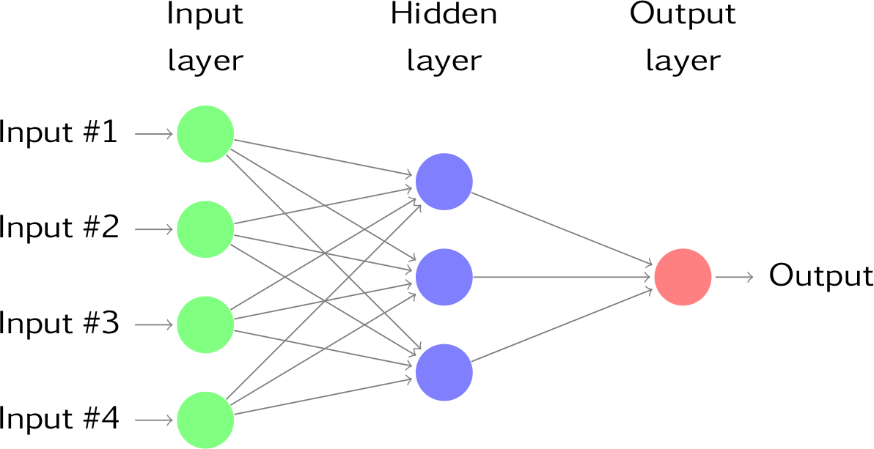
To predict image class multiple layers operate on each other to get best match layer and this process continues till no more improvement left.
Modules Information
This project consists of following modules
Upload Heavy Vehicles Fuel Dataset: Using this module we can upload train dataset to application. Dataset contains comma separated values.
Read Dataset & Generate Model: Using this module we will parse comma separated dataset and then generate train and test model for ANN from that dataset values. Dataset will be divided into 80% and 20% format, 80% will be used to train ANN model and 20% will be used to test ANN model.
Run ANN Algorithm: Using this model we can create ANN object and then feed train and test data to build ANN model.
Predict Average Fuel Consumption: Using this module we will upload new test data and then ANN will apply train model on that test data to predict average fuel consumption for that test records.
Fuel Consumption Graph: Using this module we will plot fuel consumption graph for each test record.
Screen shots
To run this project double click on ‘run.bat’ file to get below screen
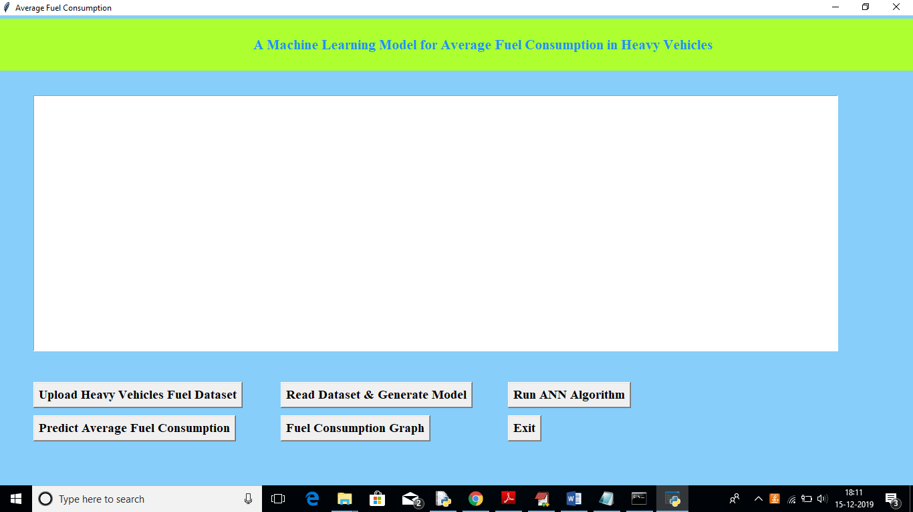
In above screen click on ‘Upload Heavy Vehicles Fuel Dataset’ button to upload train dataset
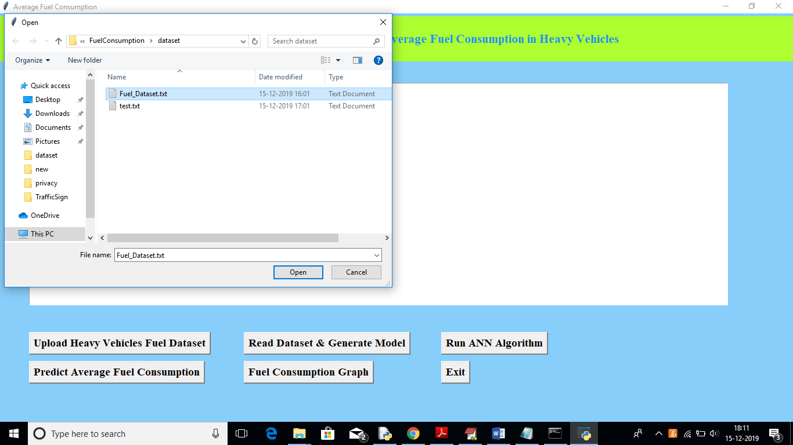
In above screen uploading ‘Fuel_Dataset.txt’ which can be used to train model. After uploading dataset will get below screen
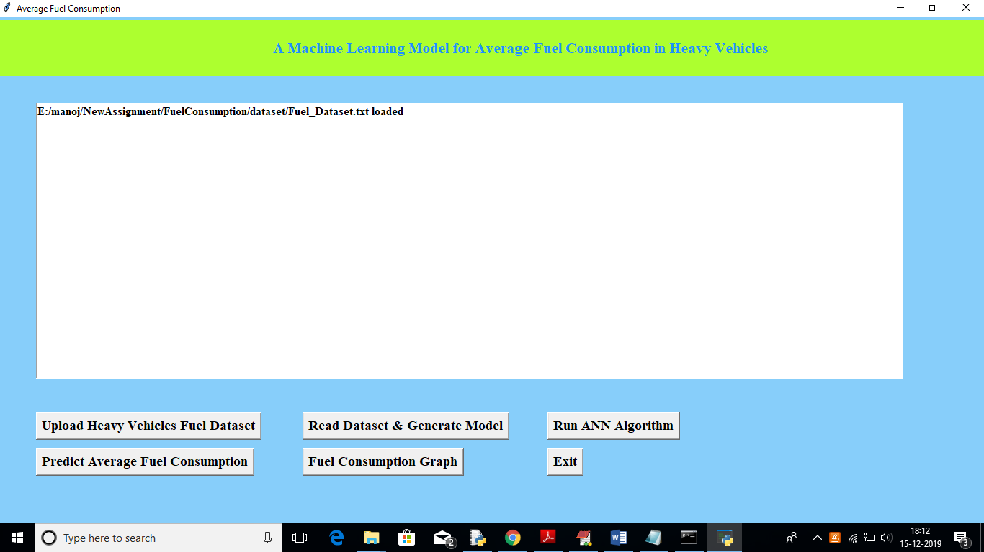
Now in above screen click on ‘Read Dataset & Generate Model’ button to read uploaded dataset and to generate train and test data
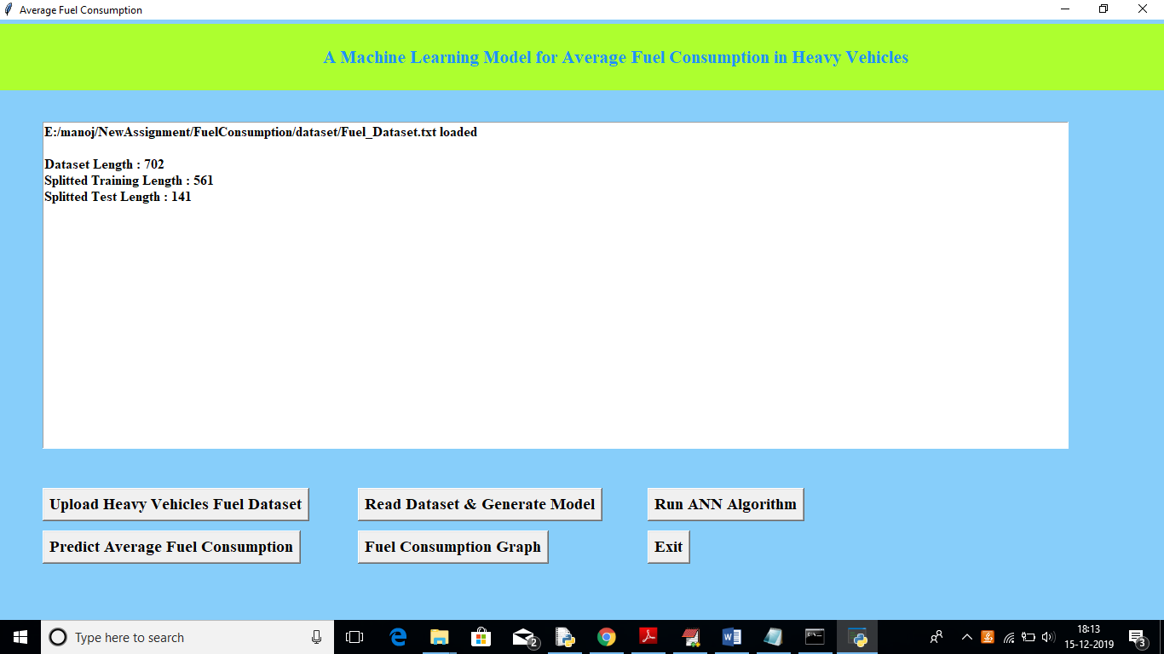
In above screen we can see total number of records in dataset, number of records used for training and number for records used for testing. Now click on ‘Run ANN Algorithm’ button to input train and test data to ANN to build ANN model.
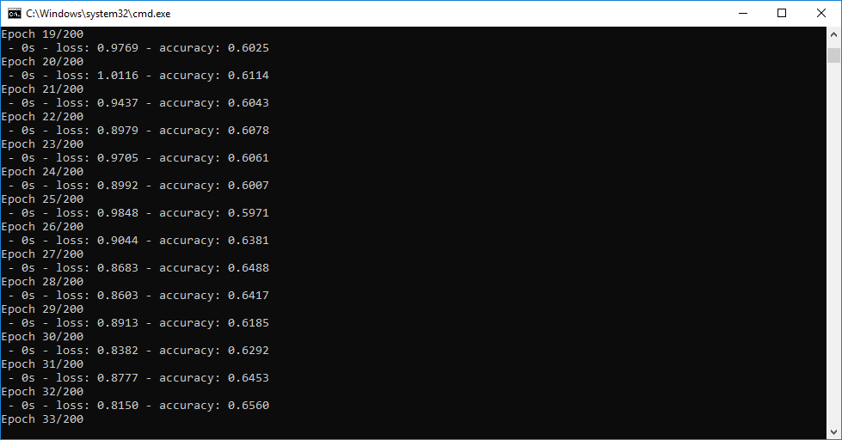
In above black console we can see all ANN processing details, After building model will get below screen
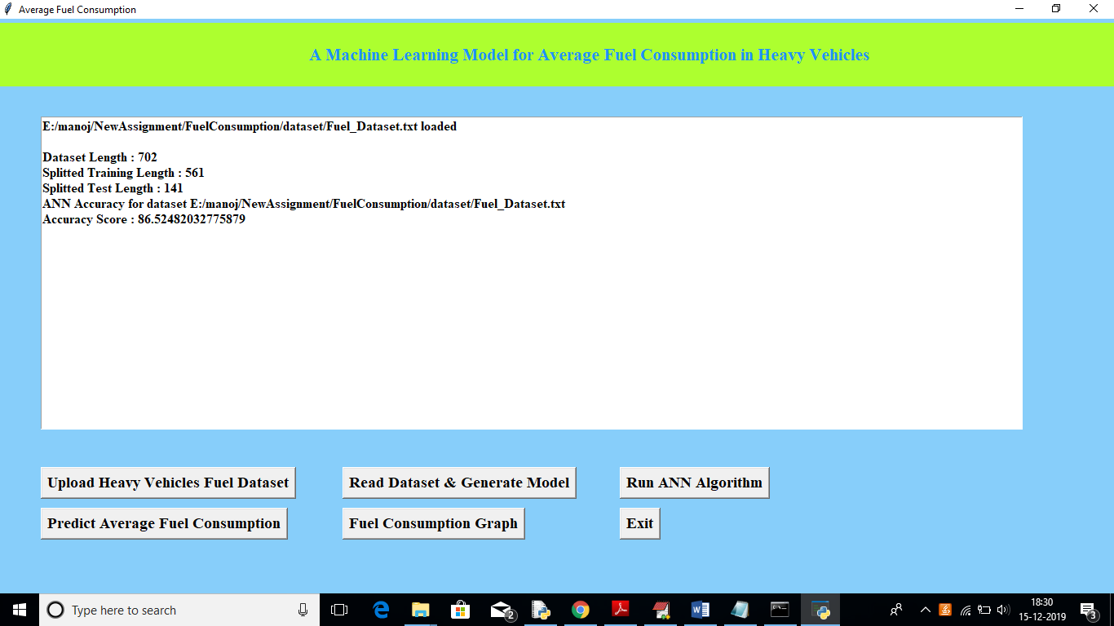
In above screen we got ANN prediction accuracy upto 86%. Now click on ‘Predict Average Fuel Consumption’ button to upload test data and to predict consumption for test data
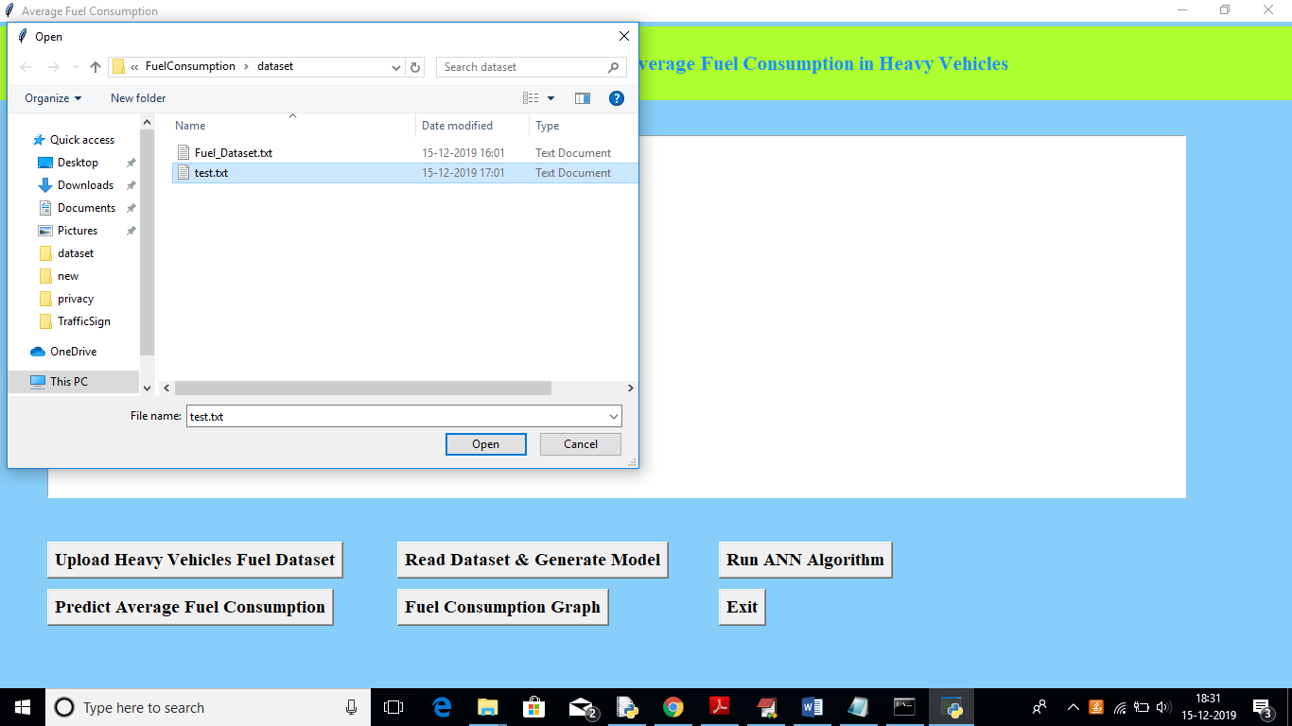

After uploading test data will get fuel consumption prediction result in below screen

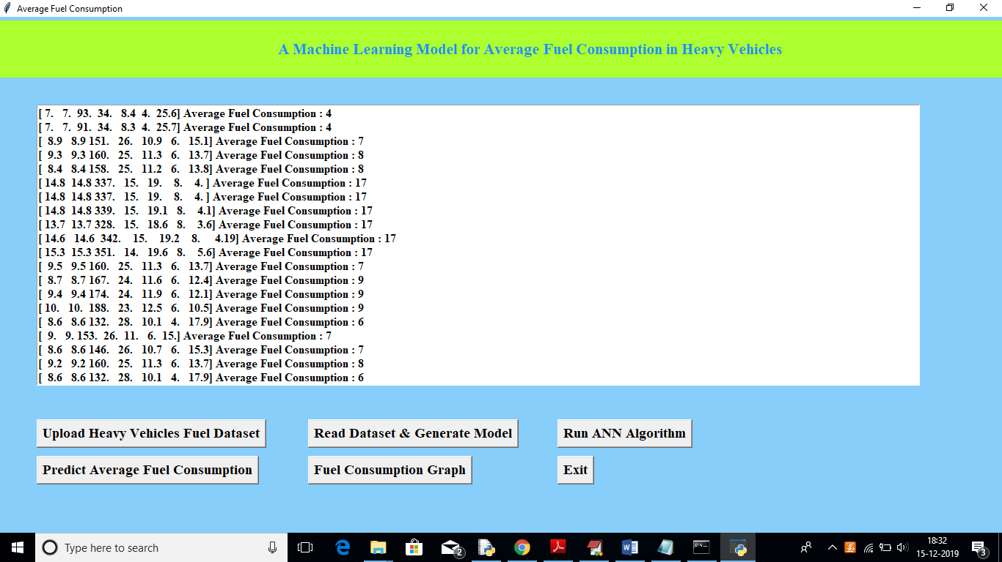
In above screen we got average fuel consumption for each test record per 100 kilo meter. Now click on ‘Fuel Consumption Graph’ to view below graph
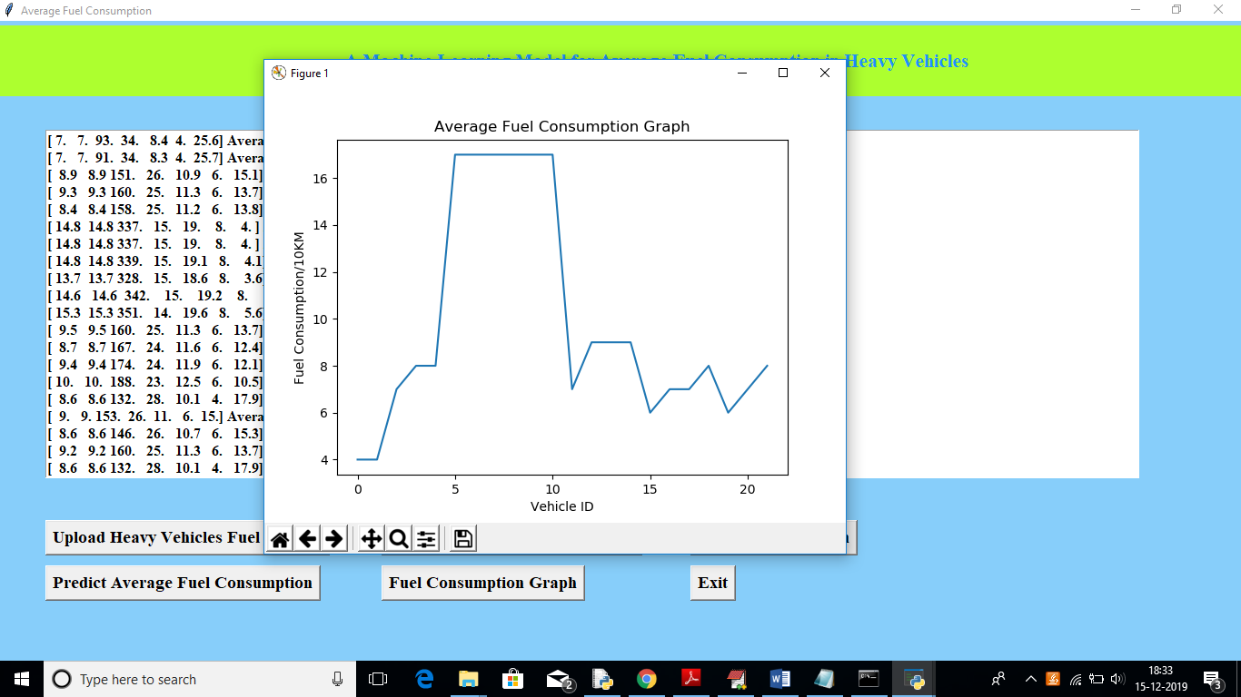
In above graph x-axis represents test record number as vehicle id and y-axis represents fuel consumption for that record.
Conclusion: Using this paper and ANN algorithm we are predicting fuel consumption for test data

